Brain Anxiety Simulator: User Manual
Introduction:
The Brain Anxiety Simulator is an educational MATLAB app designed to demonstrate how different factors can influence a person’s level of anxiety. The simulation is driven by four main inputs: the type of stimulus (auditory, visual, or olfactory), its intensity (how strong it is), its duration (how long it lasts), and whether the stimulus is familiar to the individual.
These inputs are processed through a simplified brain model that highlights the roles of four key regions. The Amygdala evaluates emotional intensity, the Hippocampus introduces the effect of memory and familiarity, the Prefrontal Cortex (PFC) provides regulation, helping to slow down or soften the reaction, and the Hypothalamus integrates these signals into the final output.
By adjusting the input sliders and options, users can observe how stimulus characteristics interact to produce an overall anxiety level, classified as Low, Moderate, or High. The result appears in two ways: as a value on the gauge, and as colors inside the brain regions.
This tool is not intended for clinical use. Rather, it serves as a teaching model, offering a clear and interactive way to explore how intensity, time, and memory can combine to shape emotional responses.
User Interface Overview:
When the Brain Anxiety Simulator starts, the main window shows the control panel on the left and the visual output on the right.
On the left side there are the following controls:
- Stimulus Type: a drop-down menu to select the type of input (Visual, Auditory, or Olfactory).
- Intensity: a slider from 0 to 10 that sets how strong the stimulus is.
- Duration: a slider from 0 to 10 that sets how long the stimulus lasts.
- Familiar?: a check box to indicate whether the stimulus is familiar or not.
- Run Simulation: a button that starts the calculation with the chosen inputs.
- Evaluated Stress Response: a text box where the final anxiety level is written in words (Low, Moderate, or High).
- Show Map: a check box that if selected, opens a separate window with a color map of anxiety levels according to the features that were chosen.
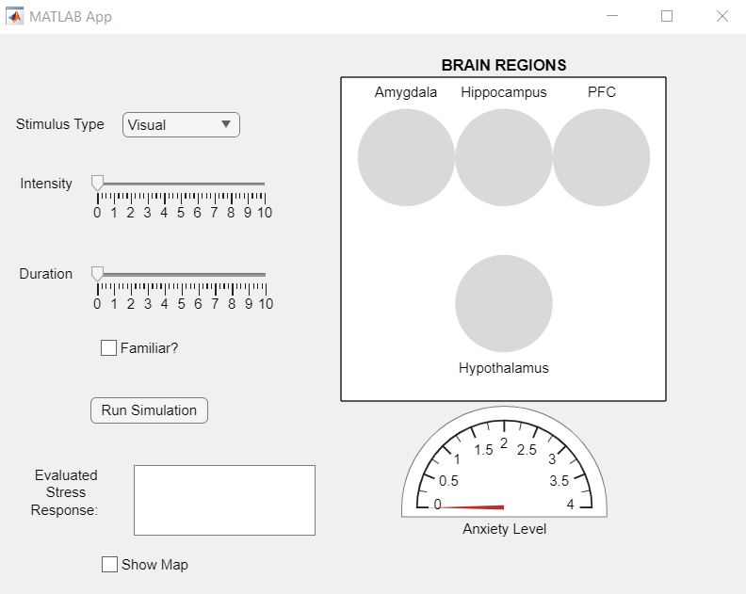
On the right side, the brain diagram shows four circles representing the relevant regions Amygdala, Hippocampus, PFC, and Hypothalamus. Their colors change according to the simulation results. Below this, there is a semicircular gauge labeled Anxiety Level, which shows the overall anxiety score.

The Brain Anxiety Simulator when first opened

Running a Simulation:
The simulator is interactive, and you can decide what kind of situation you want to test.
- Choose the type of stimulus from the drop-down menu (visual, auditory, or olfactory).
- Set the intensity by moving the slider between 0 and 10.
- Set the duration in the same way, using the duration slider.
- If you want to explore the effect of memory, check the box “Familiar?”. If you do not want familiarity to play a role, leave it unchecked.
- When you are ready, press the “Run Simulation” button.
Once you press the button, the simulator processes the inputs and updates the display.
You can also tick the “Show Map” check box before running. It adds a map of anxiety levels across intensity and duration, based on your chosen values.

Understanding the Output:
After you run the simulation, most of the results appear on the right side of the window. The brain region diagram shows four circles that represent the Amygdala, Hippocampus, PFC, and Hypothalamus. Their colors change according to the calculation: blue means low activity, yellow for medium activity, and red means high activity. These values depend on the inputs you selected.
Below the diagram there is a semicircular gauge. The needle moves to a value between 0 and 4, which represents the overall anxiety score. At the same time, the text box on the left side of the window writes the result in words: Low, Moderate, or High.
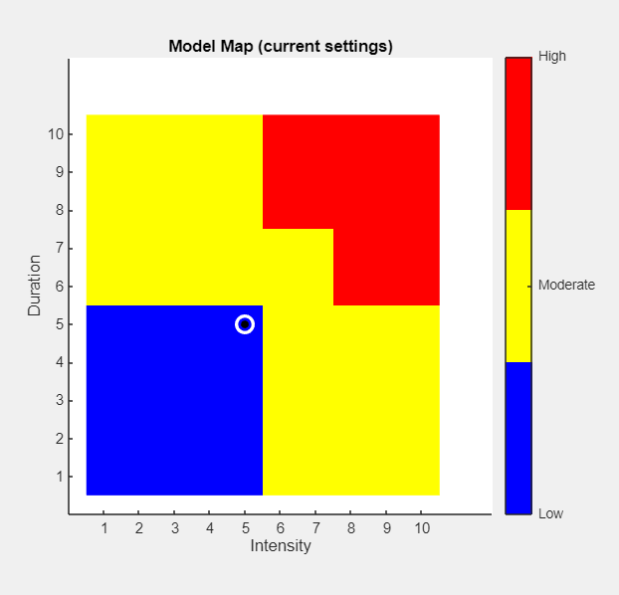
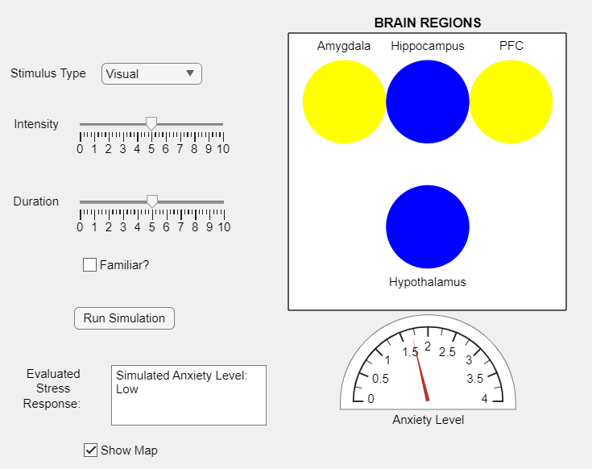
Finally, if you selected the option “Show Map", a separate window will also appear. This map displays anxiety levels for all possible combinations of intensity and duration. The colors follow the same scale (blue, yellow, red), and the map highlights the point that matches your current selection. The map itself also changes depending on the other inputs you chose, such as the type of stimulus and whether it was marked as familiar.

e.g. for outputs in case of: type – visual, intensity & duration - 5, not familiar

Notes and Limitations:
The Brain Anxiety Simulator is designed as an educational tool rather than a scientific or clinical instrument. The model simplifies complex brain processes into a small set of rules and visual elements, which makes it easier to explore but also means that it does not capture the full biological reality. For example, the simulator assumes that every stimulus is interpreted as threatening, while in real life the brain can respond in very different ways depending on context and prior experiences. The anxiety levels shown by the simulator are therefore conceptual outcomes, based on a combination of intensity, duration, familiarity, and regulation, rather than values grounded in experimental or medical data.
Despite these simplifications, the simulator provides a useful way to illustrate how multiple factors can interact to produce different outcomes. It highlights the roles of specific brain regions and shows, in an accessible format, how regulation and memory can alter emotional responses. The main purpose is to make these concepts clear and easy to understand, not to predict or diagnose actual anxiety levels.

